|  |  |  |  |  |  |  |  |  |
| --- | --- | --- | --- | --- | --- | --- | --- | --- |
| |  | | --- | | MARSHALL WOBURN II BLUETOOTH SPEAKER | |  |  |  |  |  |  | | --- | --- | --- | --- | |  | C:\xampp\htdocs\TEMP\assets\images\products\loa-marshall-woburn-2 1.jpg | C:\xampp\htdocs\TEMP\assets\images\products\loa-marshall-woburn-2 3.jpg |  | |  | **Featured information**  The Woburn II hits the highs cleanly, handles the low bass with ease, and has a clear, lifelike midrange. Bluetooth 5.0 and aptX technology provides lossless wireless audio at a range of up to 30 feet while maintaining connectivity  Price: 400$  **Specifications:**   * **Power capacity:** 130 W * **Bluetooth:** 5.0 * **Size:** 400 x 310 x 200 mm * **Weight:** 8,55 kg |

**Description:**

#### **Features of Marshall Woburn II bluetooth speaker**

Marshall Woburn II Bluetooth speaker is equipped with Bluetooth 5.0 for better wireless transmission quality, longer connection distance. DSP (digital signal processor) is upgraded to improve sound quality as well as limit distortion when increasing or decreasing bass/treble directly on the speaker. The new feature that Marshall equips on Woburn II is multi-host that allows users to quickly connect between 2 speakers together into a stereo speaker system. Besides the manual knobs, you can now also use the Marshall App on your phone to adjust EQ, switch tracks, adjust LED brightness (top) as well as turn speaker on or off (Standby) easily.

#### Marshall Woburn II's connectivity



Marshall Woburn II wireless or wired connection. In addition to Bluetooth, there are many ways to connect to the Marshall Woburn II. You can use a 3.5mm jack or RCA with your preferred analog sources. Multiple transmitters can connect to Woburn II, and you can easily switch between them

***Music playing capabilities of the Marshall Woburn II speaker***

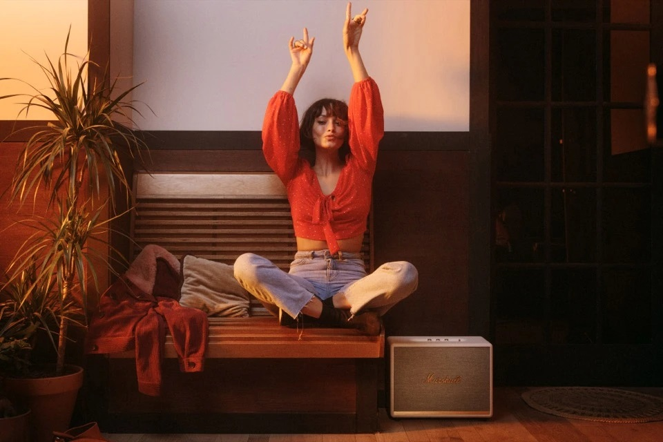

Marshall Woburn II speakers fill large rooms with sound Marshall has upgraded the internal drivers and more powerful Class D amplifiers, so that the speaker has a power of ~130W including: 2 woofers and 2 tweeters and reaches a peak threshold of over 200 Watts, more than enough to fill the sound for large living rooms.